**LAB # 06**

**UNSUPERVISED LEARNING (K-MEANS CLUSTERING ALGORITHM) AND UNSUPERVISED LEARNING (APRIORI ALGORITHM)**

**OBJECTIVE:**

Implementing unsupervised learning, K-means clustering algorithm for training, testing and classification.and Implementing Apriori Algorithm for training, testing and classification.

**Lab Tasks:**

1. **A dataset (income.csv) has been provided. Implement K-Means Clustering Algorithm on this dataset using K (number of clusters = 3). Also find out new centroid values based on the mean values of the coordinates of all the data instances from the corresponding cluster.**

* **CODE:**

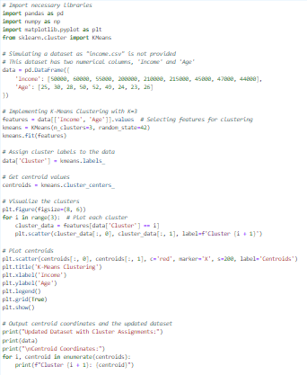

* **OUTPUT:**

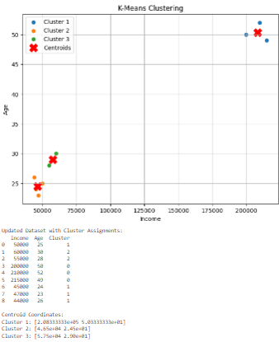

1. The following sample dataset contains 8 objects with their X, Y and Z coordinates. Your task is to cluster these objects into two clusters using K-Means Clustering Algorithm (here you define the value of K (of K-Means) in essence to be 2).

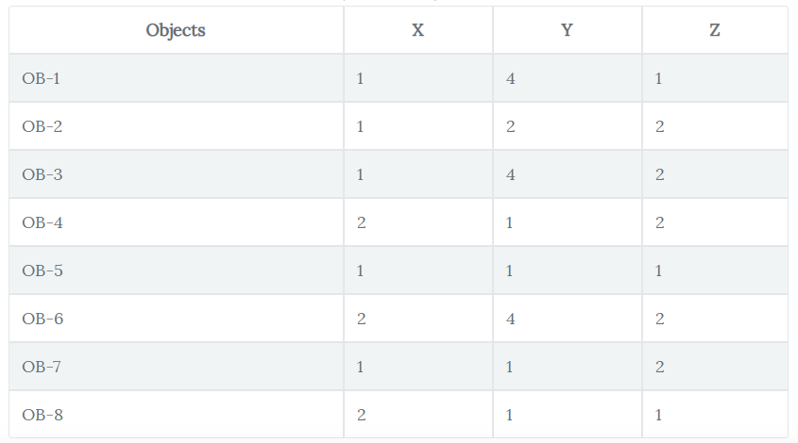

* **CODE:**

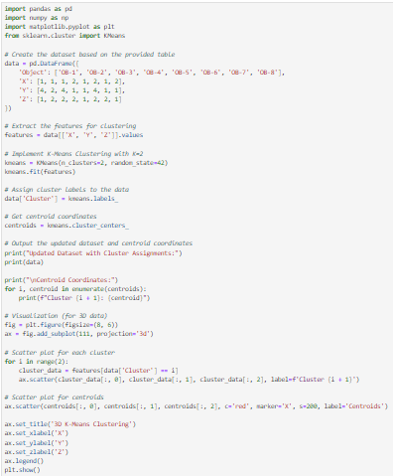

* 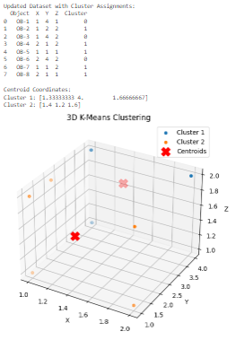**OUTPUT:**

1. Run the given code of Apriori Algorithm and show the output.

* **CODE:**

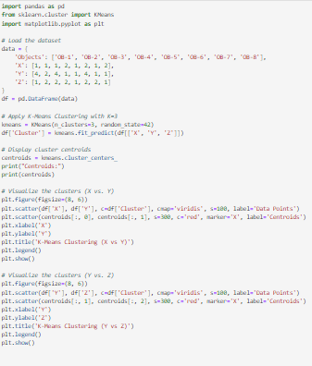

* **OUTPUT:**

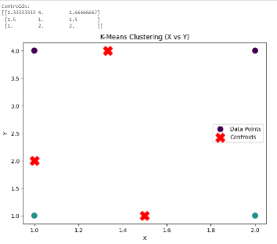

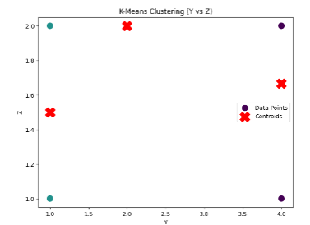

1. In given code there is a support value of at least 7%, Generate frequent item sets that have Support value of at least 5%.

* **CODE:**

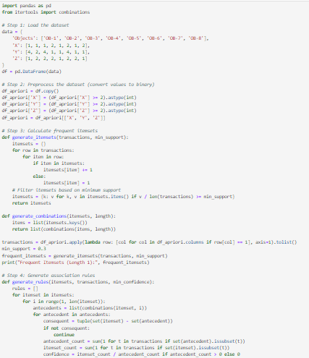

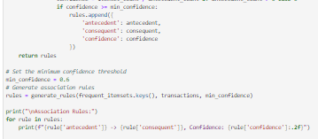

* **OUT PUT:**